**BTech ECE - Quantum University - Batch 01 - Task 02 - Design Thinking Board.**

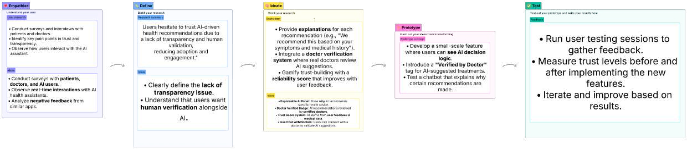

**This is the link for lucid chart as the image is not clear so refer to this link for the task in lucid chart.**

<https://lucid.app/lucidspark/ac238aca-5881-4441-9b5a-8de02c1f0718/edit?viewport_loc=-9898%2C-2916%2C22030%2C10292%2C0_0&invitationId=inv_d997daea-c527-4acc-a2fb-431c178762c7>